Toko Trailers Ltd

2.5m x 1.8m TANDEM AXLE FLAT DECK TRAILER
$7,195.00 Inc GST
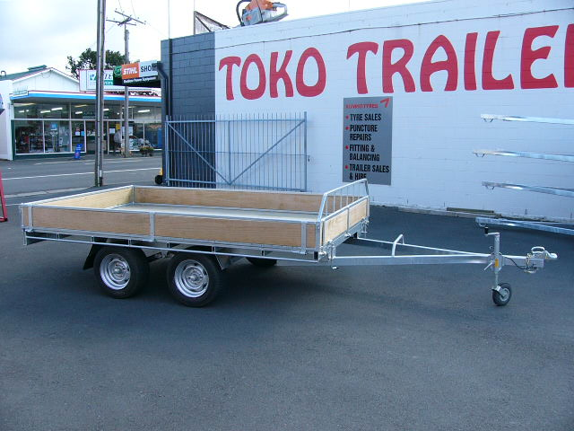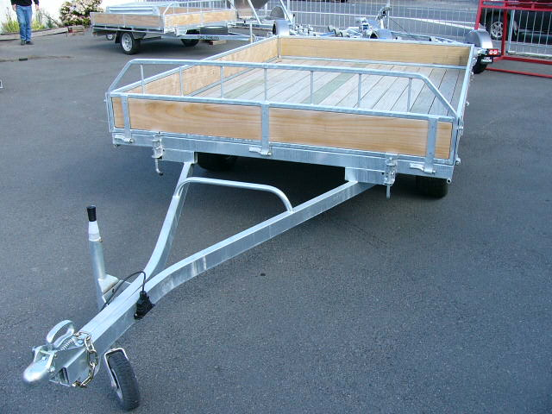

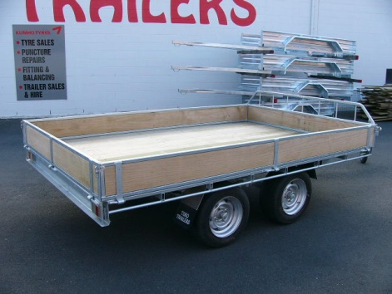
Features:
- Fully Hot Dip Galvanised
- Tandem Rocker Equaliser Springs
- Shiplap Tanalized Pine Deck
- 195/50 R13 H/D Low Profile Tyres
- Jockey Wheel
- LED Lights
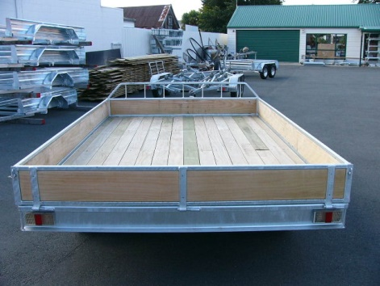
- GVM: 2000kg
- GVM: 2500kg (with brakes)

Extras:
- Galvanised Crate to suit - $1,970.00
- Hydraulic Brakes - $1,665.00 each
* All Pricing is inclusive of GST and subject to change without notice.
97 Union Street, Milton Ph: (03) 417-8727
www.tokotrailers.co.nz tokotrailers@xtra.co.nz
97 Union Street, Milton Ph: (03) 417-8727
www.tokotrailers.co.nz tokotrailers@xtra.co.nx

