Toko Trailers Ltd

8 x 5 SINGLE AXLE TOKO TRAILER
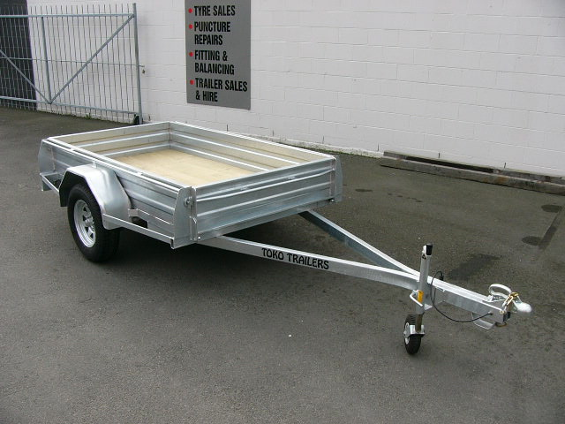
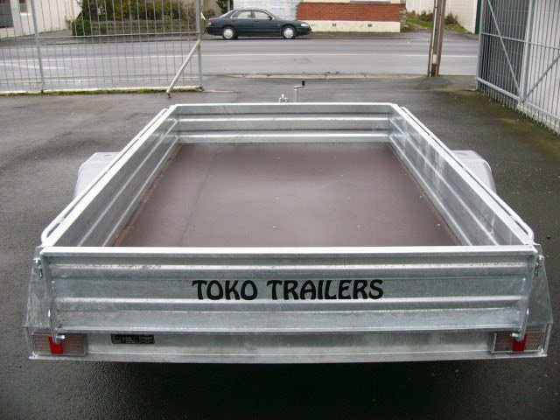
$4,423.00 Inc GST

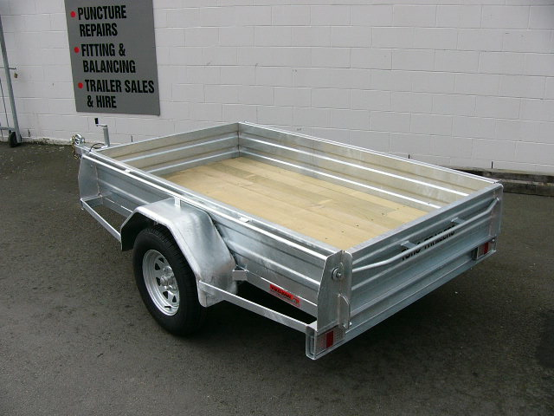
Features:
- 3mm Monocoque Design Body
- Fully Hot Dip Galvanised
- Shiplap Tanalized Pine or Trans-tex 220 Ply Deck
- 185 x 14” Tyres
- Jockey Wheel

Extras:
- Crate to Suit - $1,116.00
- Hydraulic Brakes - $1,665.00

* All Pricing is inclusive of GST and subject to change without notice.

97 Union Street, Milton Ph: (03) 417-8727
www.tokotrailers.co.nz tokotrailers@xtra.co.nz
97 Union Street, Milton Ph: (03) 417-8727
www.tokotrailers.co.nz tokotrailers@xtra.co.nx

