Toko Trailers Ltd

3 BIKE MOTORBIKE TRAILER
$4,530.00 Inc GST
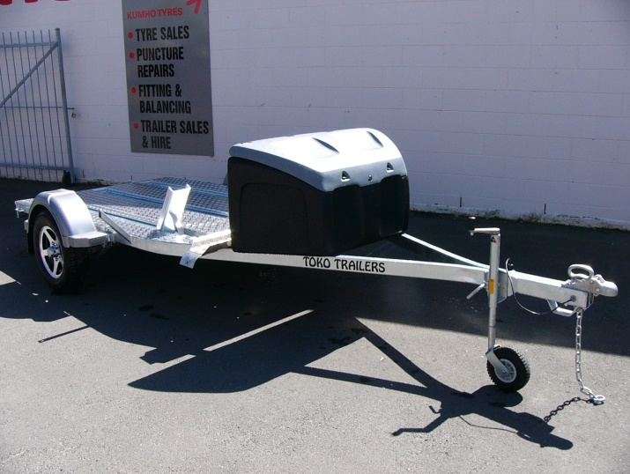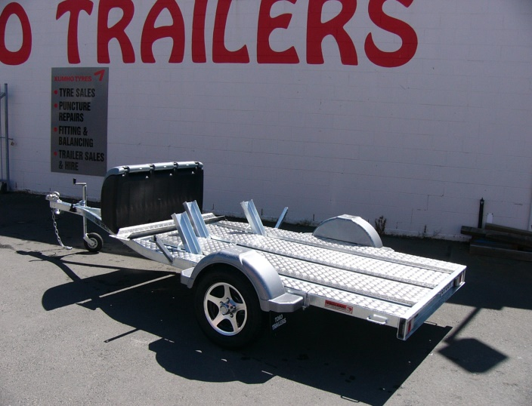
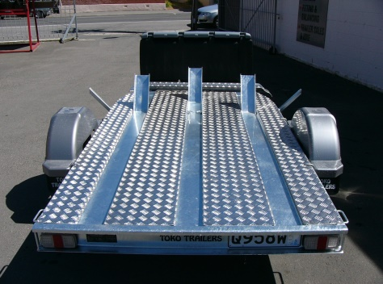
Features:
- Fully Hot Dip Galvanised
- 1500kg Springs
- 13” Light Truck Tyres
- Jockey Wheel
- LED Lights
- GVM: 1500kg

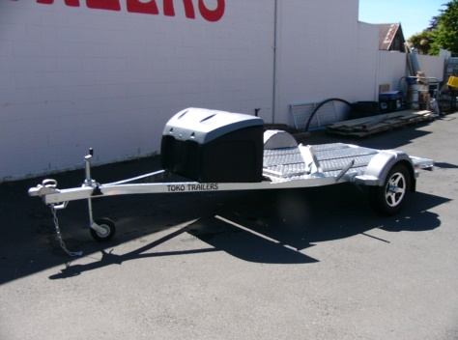
Extras:
- Alloy Deck - $428.00
- Mag Wheels - $213.00 each
- Box - $532

* All Pricing is inclusive of GST and subject to change without notice.

97 Union Street, Milton Ph: (03) 417-8727
www.tokotrailers.co.nz tokotrailers@xtra.co.nz
97 Union Street, Milton Ph: (03) 417-8727
www.tokotrailers.co.nz tokotrailers@xtra.co.nx

