Toko Trailers Ltd

11 x 6 TANDEM AXLE TOKO TRAILER
$8,272.00 Inc GST
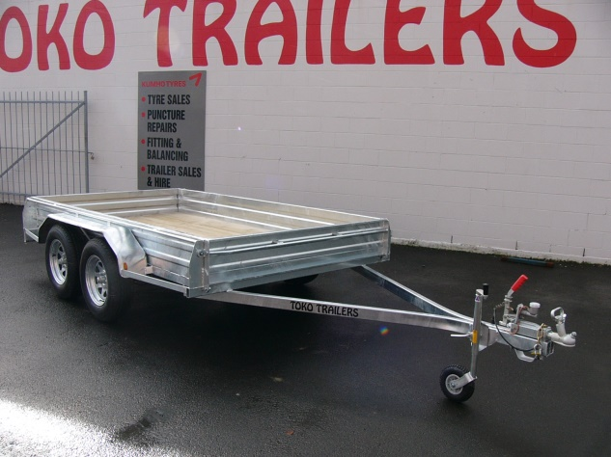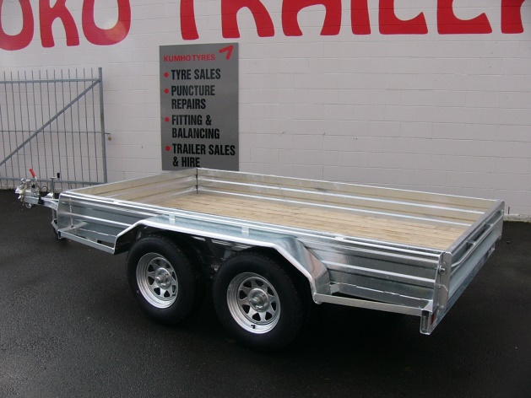

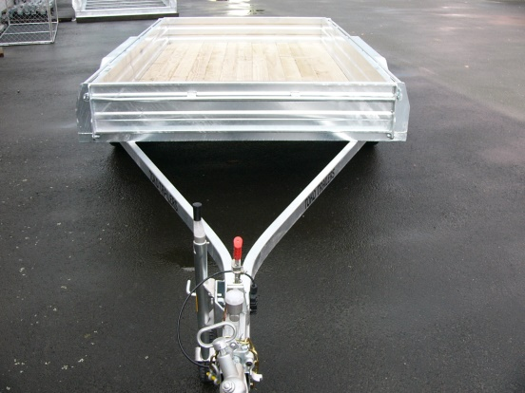
Features:
- 3mm Monocoque Heavy Duty Steel
- Fully Hot Dip Galvanised
- Tandem Rocker Equaliser Springs
- Shiplap Tanalized Pine Deck
- 14” Light Truck Tyres
- Jockey Wheel
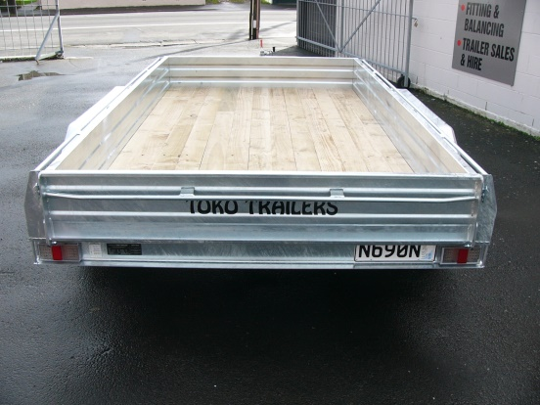
- LED Lights
- GVM: 2000kg
- GVM: 2500kg (with brakes)

Extras:
- Crate to Suit - $2,080.00
- Hydraulic Brakes - $1665.00
* All Pricing is inclusive of GST and subject to change without notice.

97 Union Street, Milton Ph: (03) 417-8727
www.tokotrailers.co.nz tokotrailers@xtra.co.nz
97 Union Street, Milton Ph: (03) 417-8727
www.tokotrailers.co.nz tokotrailers@xtra.co.nx

