Toko Trailers Ltd

ATV TOKO TRAILER
$3470.00 Inc GST
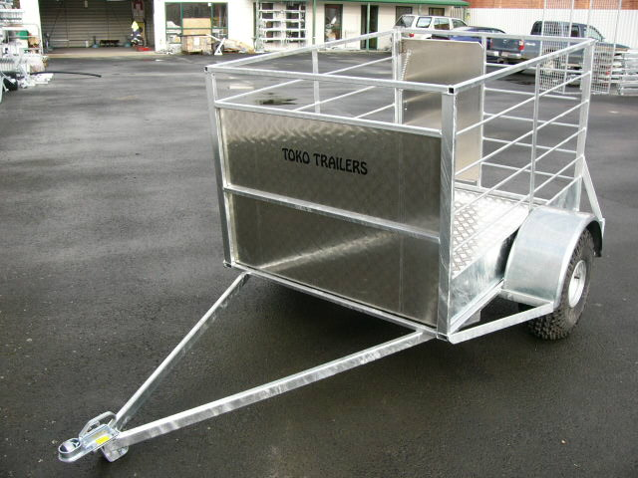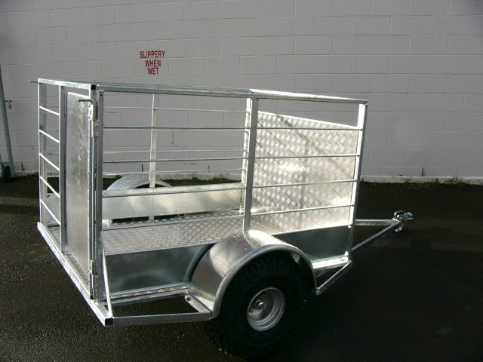

Features:
- Steel Frame fully Hot Dip Galvanised
- ATV Tyres under Steel Guards
- Treadplate Deck and Sides
- Removable Hinged Rear Gate

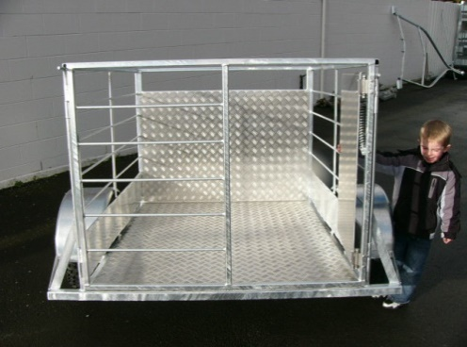
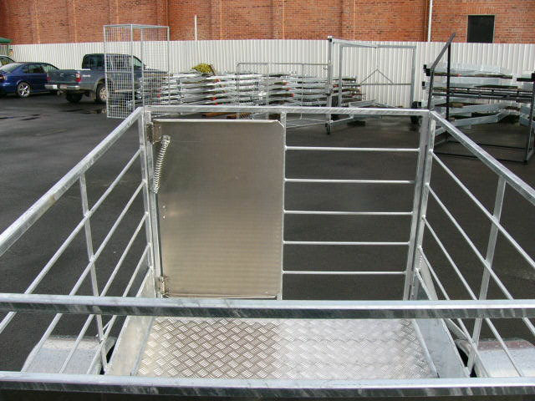

* All Pricing is inclusive of GST and subject to change without notice.
97 Union Street, Milton Ph: (03) 417-8727
www.tokotrailers.co.nz tokotrailers@xtra.co.nz
97 Union Street, Milton Ph: (03) 417-8727
www.tokotrailers.co.nz tokotrailers@xtra.co.nx

