P
Toko Trailers Ltd

2.5m x 1.8m SINGLE AXLE FLAT DECK TRAILER
$5964.00 Inc GST
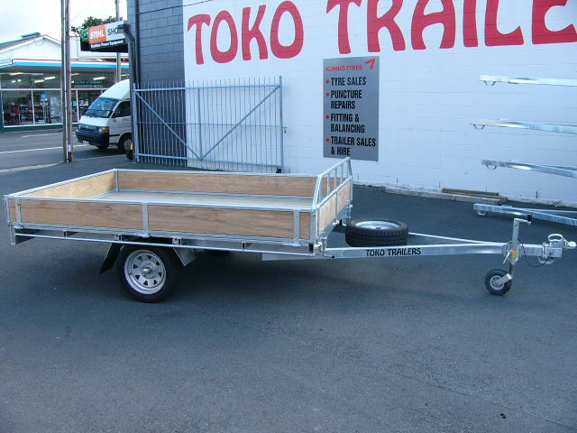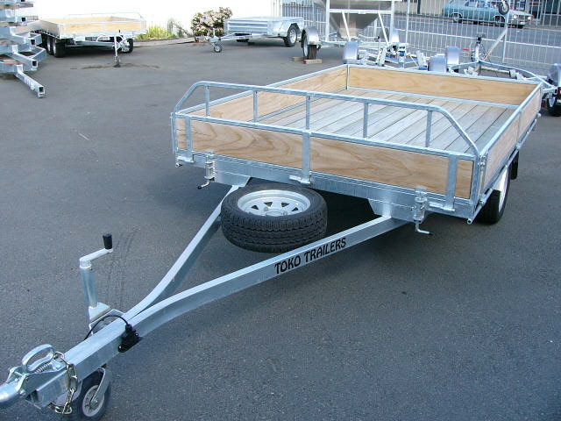
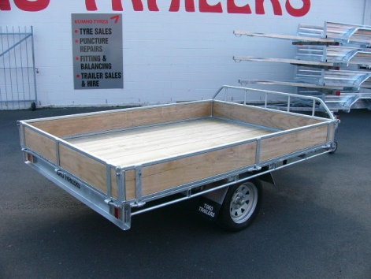
Features:
- Fully Hot Dip Galvanised
- Euro Grip Deck
- 195/50 R13 H/D Low Profile Tyres
- Mounted Spare Wheel
Price ins
On-Road
Costs
- Jockey Wheel
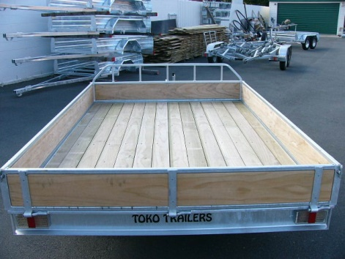
- LED Lights
- GVM: 1500kg

Extras:
- Galvanised Crate to suit - $2167.00
- Hydraulic Brakes - $1832.00 each
- Tipper Option Fitted – Starts at $3300
97 Union Street, Milton Ph: (03) 417-8727
www.tokotrailers.co.nz tokotrailers@xtra.co.nz
* All Pricing is inclusive of GST and subject to change without notice.
97 Union Street, Milton Ph: (03) 417-8727
www.tokotrailers.co.nz tokotrailers@xtra.co.nx

