Toko Trailers Ltd

6 x 4 SINGLE AXLE TOKO TRAILER
$3,457.00 Inc GST
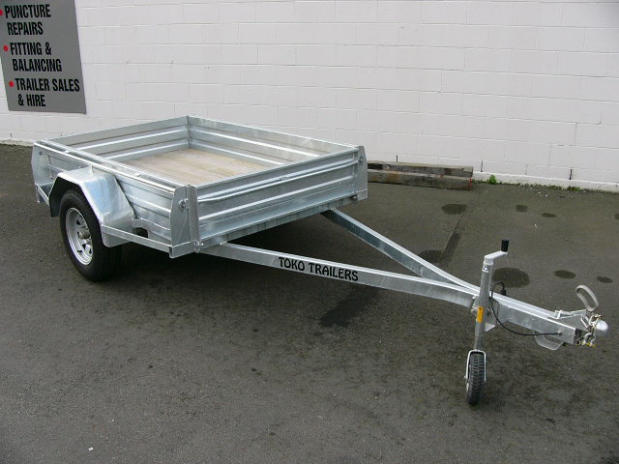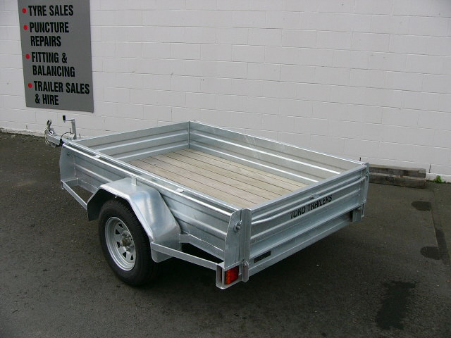

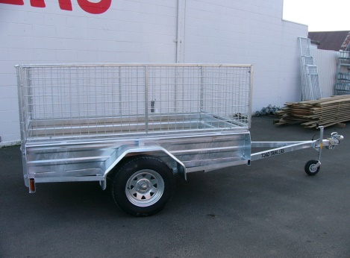
Features:
- 3mm Monocoque Heavy Duty Steel
- Fully Hot Dip Galvanised
- Shiplap Tanalized Pine Deck
- 13” Light TruckTyres
- Jockey Wheel
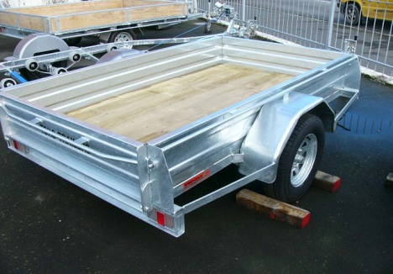
- GVM: 1340kg

Extras:
- Galvanised Crate to Suit - $770.00
* All Pricing is inclusive of GST and subject to change without notice.
97 Union Street, Milton Ph: (03) 417-8727
www.tokotrailers.co.nz tokotrailers@xtra.co.nz
97 Union Street, Milton Ph: (03) 417-8727
www.tokotrailers.co.nz tokotrailers@xtra.co.nx

