Toko Trailers Ltd

3.0m x 2.0m TANDEM AXLE FLAT DECK TRAILER
$8882.00 Inc GST
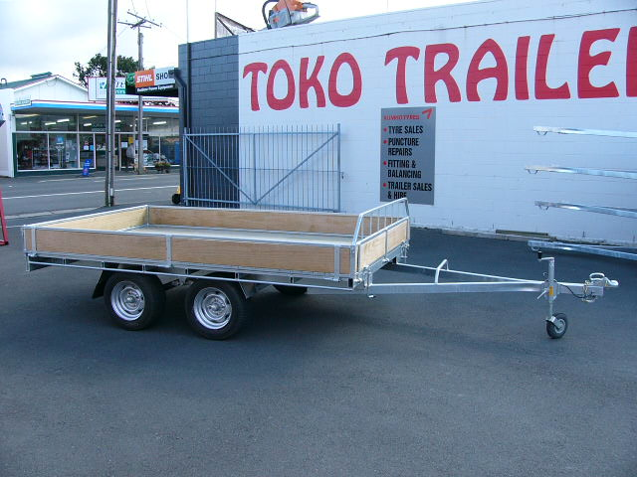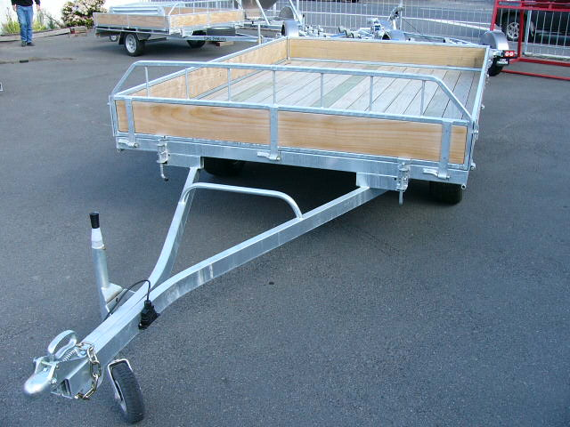
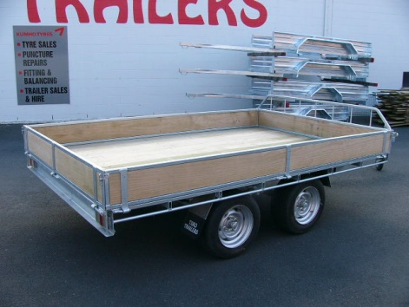
Features:
- Fully Hot Dip Galvanised
- Tandem Rocker Equaliser Springs
- Euro Grip Deck
- 195/50 R13 H/D Low Profile Tyres
- Jockey Wheel
- LED Lights
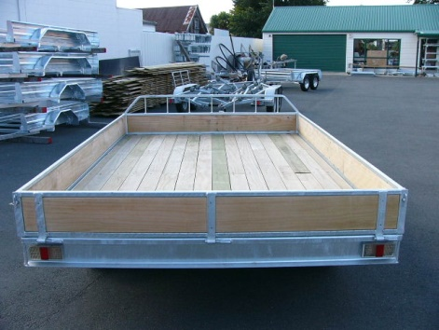
- GVM: 2000kg
- GVM: 2500kg (with brakes)
Extras:
- Galvanised Crate to suit - $2,407.00
- Hydraulic Brakes - $1832.00 each
- Tipper Option Fitted – Starts at $3300
* All Pricing is inclusive of GST and subject to change without notice.
97 Union Street, Milton Ph: (03) 417-8727
www.tokotrailers.co.nz tokotrailers@xtra.co.nz
97 Union Street, Milton Ph: (03) 417-8727
www.tokotrailers.co.nz tokotrailers@xtra.co.nx

