Toko Trailers Ltd

7 x 4 SINGLE AXLE TOKO TRAILER
$3,599.00 Inc GST
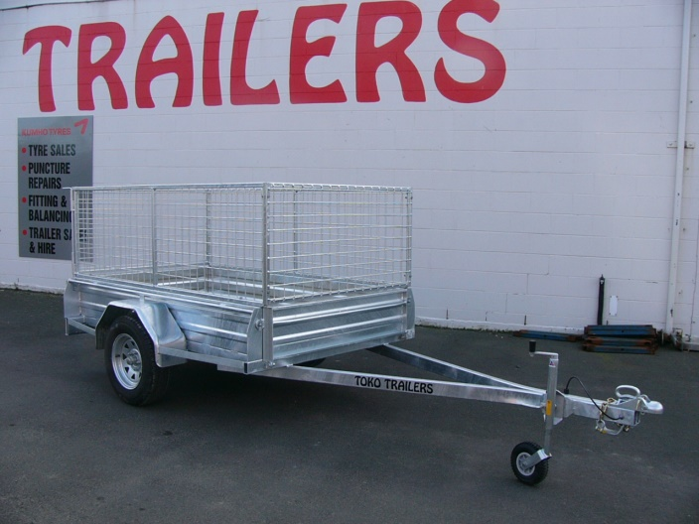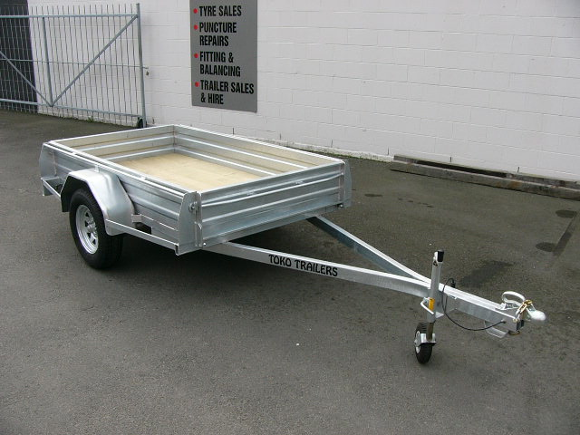
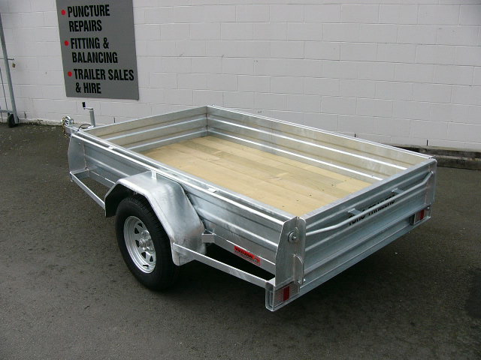
Features:
- 3mm Monocoque Heavy Duty Steel
- Fully Hot Dip Galvanised
- Shiplap Tanalized Pine Deck
- 13” Tyres
- Jockey Wheel
- GVM: 1340kg

Extras:
- Galvanised Crate to Suit - $889.00
* All Pricing is inclusive of GST and subject to change without notice.

97 Union Street, Milton Ph: (03) 417-8727
www.tokotrailers.co.nz tokotrailers@xtra.co.nz
97 Union Street, Milton Ph: (03) 417-8727
www.tokotrailers.co.nz tokotrailers@xtra.co.nx

