Toko Trailers Ltd

5 BIKE MOTORBIKE TRAILER
$7857.00 Inc GST
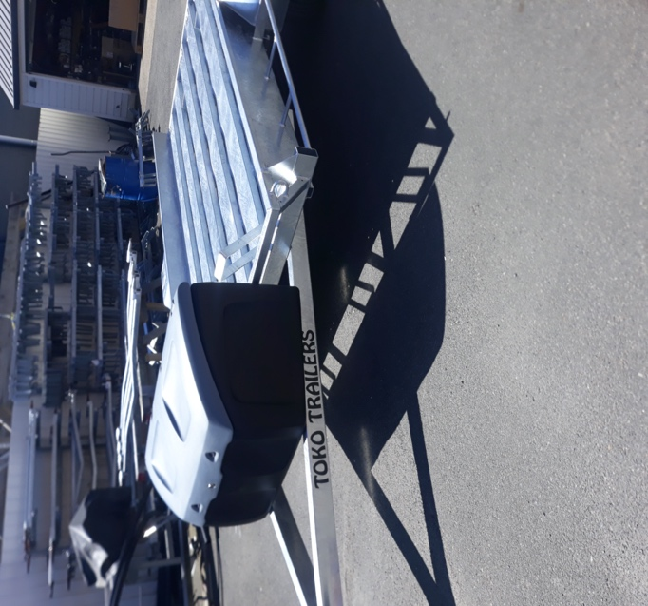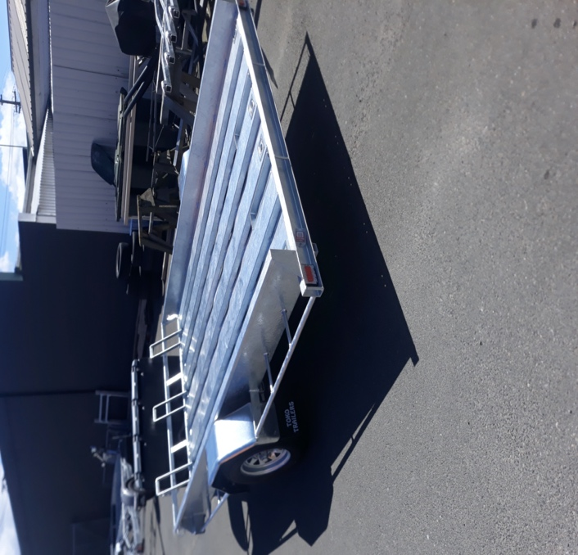

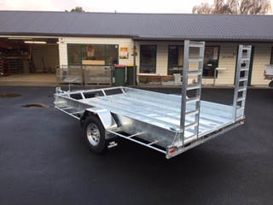
Features:
- Fully Hot Dip Galvanised
- 1500kg Springs
- 14” Light Truck Tyres
- Jockey Wheel
- LED Lights
- GVM: 1500kg

Extras:
- Alloy Deck - $654.00
- Mag Wheels - $258.00 each
- Box - $586
* All Pricing is inclusive of GST and subject to change without notice.

97 Union Street, Milton Ph: (03) 417-8727
www.tokotrailers.co.nz tokotrailers@xtra.co.nz
97 Union Street, Milton Ph: (03) 417-8727
www.tokotrailers.co.nz tokotrailers@xtra.co.nx

