Toko Trailers Ltd

9 x 5’6” TANDEM AXLE TOKO TRAILER
$6,438.00 Inc GST
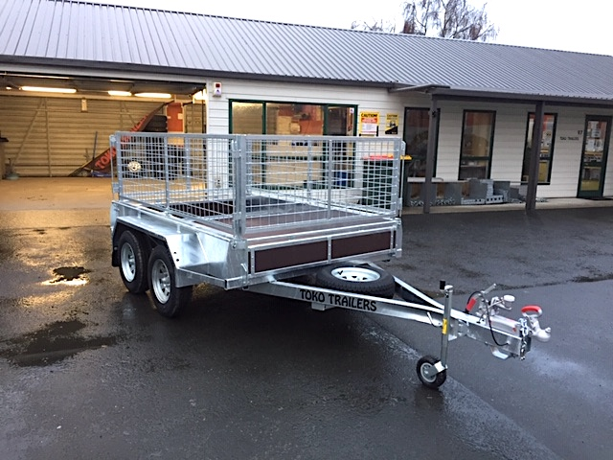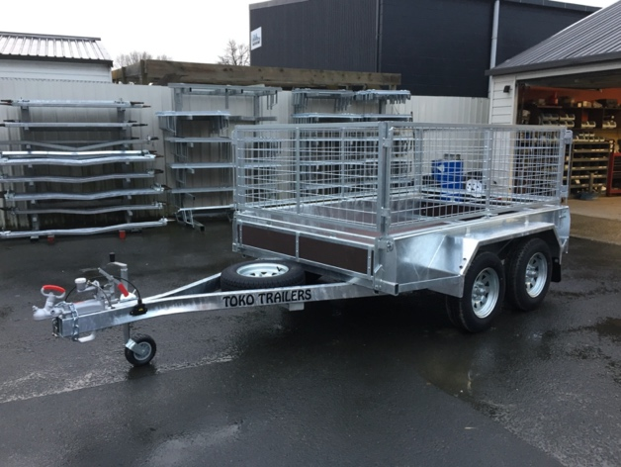

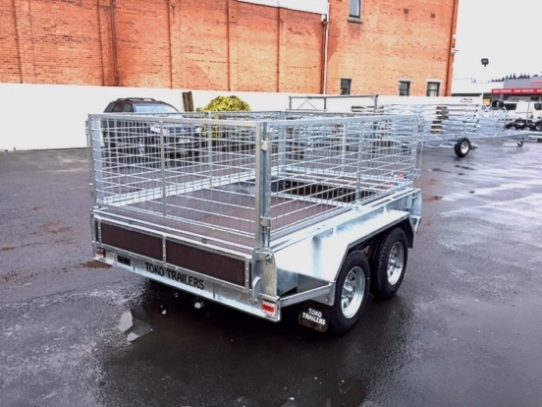
Features:
- 3mm Monocoque Heavy Duty Steel
- Fully Hot Dip Galvanised
- Tandem Rocker Equaliser Springs
- Gripdeck Euro
- Deck
- 14” Light Truck Tyres
- Jockey Wheel
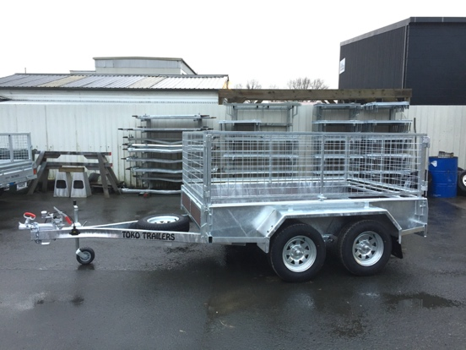
- LED Lights
- GVM: 2000kg
- GVM: 2500kg (with brakes)
Extras:
- Crate to Suit - $1,787.00
- Hydraulic Brakes - $1665.00
- Tipper Option Fitted – Start Price $3000
* All Pricing is inclusive of GST and subject to change without notice.

97 Union Street, Milton Ph: (03) 417-8727
www.tokotrailers.co.nz tokotrailers@xtra.co.nz
97 Union Street, Milton Ph: (03) 417-8727
www.tokotrailers.co.nz tokotrailers@xtra.co.nx

